Discover what insights lie hidden in our data.

## What is the dataset challenge?

The challenge is a chance for students to conduct research or analysis on our data and share their discoveries with us. Whether you're trying to figure out how food trends start or identify the impact of different connections from the local graph, you'll have a chance to win cash prizes for your work! See some of the [past winners](https://www.yelp.com/dataset/challenge/winners) and [hundreds of academic papers written](https://scholar.google.com/scholar?q=citation%3A+Yelp+Dataset&btnG=&hl=en&as_sdt=0%2C5) using the dataset.

## The Challenge

We challenge students to use our data in innovative ways and break ground in research. Here are some examples of topics we find interesting, but remember these are only to get you thinking and we welcome novel approaches!

### Photo Classification

Maybe you've heard of our ability to [identify hot dogs (and other foods)](https://thenextweb.com/insider/2017/06/30/yelp-created-the-hotdog-app-from-silicon-valley-only-better/#.tnw_8SxfaGk8) in photos. Or how we can tell you if your photo will be [beautiful or not](https://engineeringblog.yelp.com/2016/11/finding-beautiful-yelp-photos-using-deep-learning.html). Can you do better?

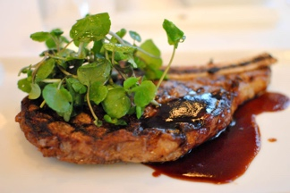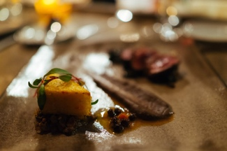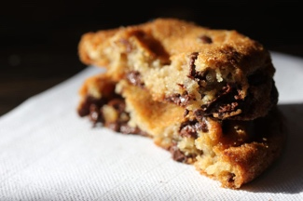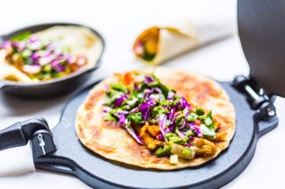

### Natural Language Processing & Sentiment Analysis

What's in a review? Is it positive or negative? Our reviews contain a lot of metadata that can be mined and used to infer meaning, business attributes, and sentiment.

### Graph Mining

We recently launched our [Local Graph](https://www.yelp.com/developers/graphql/guides/intro) but can you take the graph further? How do user's relationships define their usage patterns? Where are the trend setters eating before it becomes popular?

This set includes information about local businesses in 11 metropolitan areas across 4 countries. Round 11 has kicked off starting January 18, 2018 and will run through June 30, 2018.

## The Awards

If you are a student, you’ll have the opportunity to win one of ten awards for $5,000. We’ll judge submissions on their technical depth and rigor, the relevance of the results to Yelp, our users, or the field, and finally their novelty, uniqueness, and their Yelpy-ness. Please note: if contest participants work with professors or other non-student advisors to craft a submission, only the students are eligible for prize consideration--any non-student advisors must be credited only in an advisory capacity and not as co-authors.

Additionally, if you publish a research paper about your winning research in a peer-reviewed academic journal, then you’ll be awarded an additional $1,000 as recognition of your publication. If you are published, Yelp will also contribute up to $500 to travel expenses to help you present your research using our data at an academic or industry conference.

The deadline for the eleventh round is **June 30, 2018**. You can submit a research paper, video presentation, slide deck, website, blog, or any other medium that conveys your use of the data. If you have any questions regarding the challenge, feel free to contact dataset@yelp.com.   
  
**Please read the**[**Dataset Challenge License**](https://s3-media2.fl.yelpcdn.com/assets/srv0/engineering_pages/af4b9cebfb4f/assets/vendor/dataset-challenge-dataset-agreement.pdf)**and**[**Dataset Challenge Terms**](https://s3-media2.fl.yelpcdn.com/assets/srv0/engineering_pages/547693935ebd/assets/vendor/yelp-dataset-challenge-round-11.pdf)**before continuing.**